_{(n&*Mr(fr} q-5
ffi
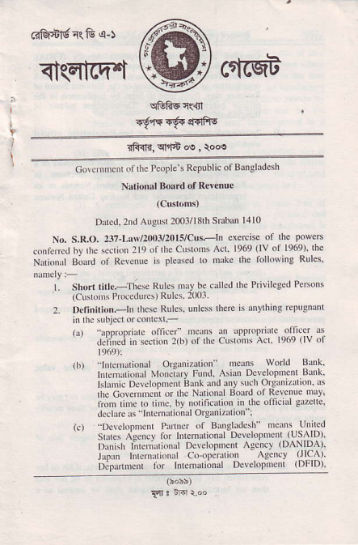
_{dqEfcq't} cetmt
ifu<,qff'td'qooe
Corcitrnont oilhc PeoPle s RePublic ofBansludesh
Narional Bo.rd oJ Rev€nue
(customt
Ddcd, 2rd Aueusl 20o3/l8th SEun 14l0
No. S.R.O. _{237-Lo$/!003/20r5/Cus-tn} cxercise or the pow€ts f.nrc.red h! Inc..\ ron lla ol _{rle c'} ^{qcrn'} A( _{lac,q'lv'} ^{n6or'} Ihe Nn,"h'l B;Jrd ol R.ren.'e F pler'ed o mrle rh' roll'"re Rlles nnnPly:
L Short lill..--These Rulos mrv be..llcd Ihe Prilile8ed Pcrsons (Ctrstonrs Pio.edur.s) Rulcs- 2001.
2. Dclinilion.-h lhese ltulcs. unle\s lhere is nnrlhrn8 FPugnant in rhc $rbjet dr.o err.-
'f(er" ^{'c'n'Jn} _{upr' flJrc} oifit<' r'
.|.:ii,,eJ r, *ct!, ^{lrl'r} _{"r} rhe . hr'i'ir\ a.r' lqa _{lv} ^l
_{(b)} ^{-'lntetrlrionrl} OrA illri.n melns World ^{Bink' '} lnlemdiDnd ^{iUon.i} _{v} Fund. Asidn Dcrelopte Bonk' l:lJ'i'. Dc'el"p. e i Brrk _{xnd !n,} 'u'r' o'Pxr /xr'on h
rhe Coter,"ncrir ur rh. \rr'onJr Bo.'rd ol Rc\cnue r"v
hlm lime to rinc. bv trotilicarion in Ihe _{oticiil} gi?crte. dcchrcrs _{nrrcddioiDlOrA} izrlion :
_{rc'} ^{-DJ\(l.oncnr} _{Prlfr} '{ _{BrnAl'Jc'h} ncr$ Urir'J srb Aorv r,.' lricrnir.onJ D$el.pnci,Us^lD).
Dinish literit(nntrl Developme.t _{Ae.ncv} (DANIDA). lNrn lNernrrtund _{Co opdrtion} Agencv {llcA).
o3p*rnrcn itt hemdri;nal _{Delelopnrent} (DFlDl,
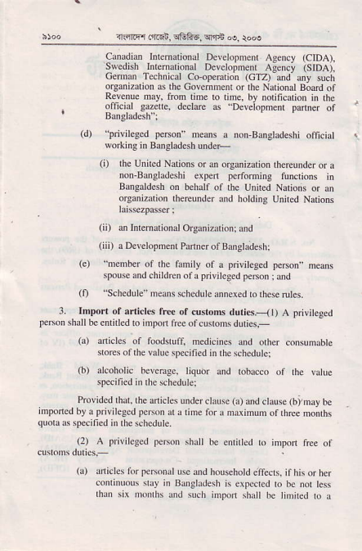
^{?l,rnEr} _{m6i, cEkE,} ^{q'tB oe,} ro@
Canadie hlenadond Dcvelopmenr As€.cy (CIDA), swedish lnrenational Dwcloineir ^{Asflci isrDAi,} Geman Tohnical Co opemiioil (cTz)-and' uy such organizarion s tne Covemnenr or rbe Nalional B;dd of Revenue dax from tlhe to tine, by notification in rhe
. ^{oljcrJl} _{erkue.} decltre a\ "Deleiopmen' prnner of ^{bugrmesn} I
^{(d)} _{brivileged} pe6on ncms u non-B&_qladeshi oficial worhins in Bangladesh under-
(i) lhe Unned Nations or d orSanizaliob uereu.der o! a non-Bangladeshi eipdt pertominB tuncrions i.
Bangrld6b on bebalf of rh€ United Narions or an
organiation rhereunder ond holdins U.ned Nariors
rtu$ezpdser;
(ii) m Inrenarional Orean izaiion; and
(iii) a Dev€lopme Panner ol Banglaitesh;
(e) member of the fanity of a privileged person,, means spouse and childie. of! privilc8€d pe$on jd
^{(f)} "Schcdule neaN $hedlle annexed lorheserul*. 3. hport of arliclg fre of dsroru duri6.- {l) A piriteged pefton shall bc cnriled ro import frce of cusrons duties.-
_{{a)} o iclcs of f@dstuli nedicines and orhq mnsum@e stores of the valuc spec ified i. thc schedule:
^{(b)} arcoholic bevera8c, liquor and tobacco of lhe valLe specified nr the schedule:
Elvided rhar, rhe anictes under
inponcdby a privile8cd person ar a tim. quou as specified i. rheschedule.
clamc ^{(a)} ud dausc ^{(b),may} be for a maximun of lhree mo hs
(2) A prilileeed peMn shlll be entnted lo import free of ctlrqns du'fsj-
(a) aaicles lorpe^onaluse drd household e'ffcds, ithisorher conr.uous slry in B,nglddesh is expe.red ro bc nor tess rhln six moDrhs and such nnpon shall bc tinned ro a
{r mr 6u'cn, _{sGfie,} ^{q'1+} N, {o.!
mdimun Cosl, lnsurdce tod _{Frcight} (CII) !.lue of tlka fifty rhoussd _{for lhe nrst} yee Bnd shall b€ nnPoned wilhin rho p$iod _{ot} c r nonrhs lon rh. daE of h' or hs lir{ a[ival in Baogladesh _{dd lhis} p.riod nay, oo sntisfacbry
gouods, be exiended by mdns period of lbree hoolhs bv de comissioner o' .us!om. corcemed Jnd bJ rhe \oiional Bord ol Releriue ^{for} _{"u(h fudher} penod a: n
_{an.rexpiry of'he} penod _{ol one} y.d ol conlrndou' sray In
(b)
Bdnslad..h. ^{dicles ol} _{FMnal} u'e dd hod'ehold errd' !p lo rne cost. _{Insurance and Feiglt} (cID valuc of taka _{fifteen tholsmd} p€r yee lor _{tne rexr lwo} yemr fld
_{A} pririLged peen shau be enfiled lo impofi free of 0)
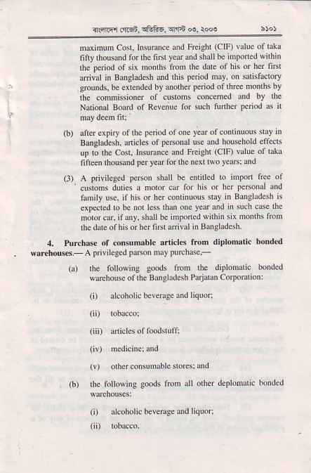
⁻ custons duties a notor cr for his or her peBond dnd f.mily use, if hh or lrer condnlous stay in Bdgl.desh is eip4ted ro b€ nor 16\ ^{rhd one} _{teo} Jnd _{'n such cae} 'he moror!o, ifdy..hall _{& inponed} w'Lhin sii mon'hs rrcm $e date of nis or her fiNt aftival i. Baogladesn
4. Pu.ch$e ol onsumble a.1icl6 fron diplomalic bonded *rnhous.- _{A} privilegcd pson _{nay} puEhdq-
(a) _{rhe following} goods lron tbe diplonaric bonded Pdehouse of lh€ Bangladesb P&jaran Coipomrion:
(i) alcoholic beledge ud liquol:
(iiD dicl€s of f@dstur;
(v) o$er consunabl€ stores: d"
rn followine goods tron all oth* d€plohalic bonded (i) llcoholic bev€nge and liquor;
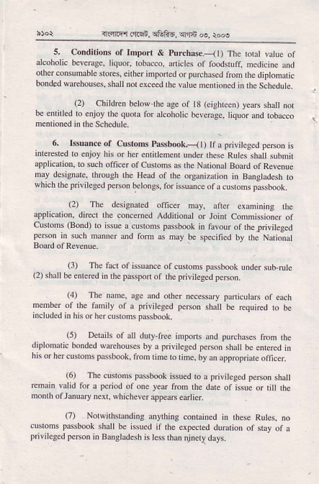
illrlmr _{.n} qn, q6fi8, ^{qnb} oe, \oN
s. Condilions oI Import & ^{puRh.se.-il)} The lolll valuc of alcoholic beveDse, liquor, tobacco, onicles of foodsrufi mcdicine and olher consumable stofts, eifter iDpoded or ^{purchlsed} fron dc diDlomalic bonded wd€houscs, shall nol exced de valle nenlioncd in rhe Schcdute.
(2) Children hetow.tbe aee of 18 (eiehFen) yeaB shall not be enrirl.d ro eniov 'h0 quorr ro! Jcohotic beeemee. Iiquor ond roDalco m€nrioned in rhe Scbedule
6. I$uanc€ or _{custom} ^{pa$book.--{ I} ) ||; _{Eivircged} p€Mn is 'nrerest€d ro enjoy his or her enridenenr under desc Rutes sbal slbnn .ptiicdion. ro such ofiic.r of Cusloms as rhe Nadonll Board oa Revenue may dcsiSnlte, tbmuCb de Head oi lhe olBanizdrion in Bangladesh to wbich lne prililesed psson belongs, lor hsuancc of a cusroms passbook,
(2) The designared oflcer may, aner cx.ojning rlE rpplic.tion, diet the concemed Addilioral or Joint Condissioner oi cusroms ^{(Bond)} ro i$ue a custods pssbooh in favonr of rhelrivileged person r. sucb ndnner and fom 6 my be sp4ined by rhc Nariond
Board of Rerenue.
, rr The tucr or 'sJance or cu,bn\ pJ..mot mder ^{rub ruh} (2) shall b€ enrered in$c pdsport ot lhe pdyileged peen.
^{(.1)} The none, Ige r.d orher ^{necess!.y paniculaN} of e&h membcr oi tbe fomily of a priviteged ^{pe$on} shnl bc rcquiEd to be includ.d in his or bercusroms p6sbook.
(5) Dchih of 0ll ddy free impons and ^{puruhass} frcm rh€ diplodatic ^{bonded *arehouses} by a pivilcged p€rsDn shdl be cmeled in ^{his or her cNtods passbook,} fron tihe to rime, by an rppropride oficer,
⁽⁶⁾ The customs ^{plssbok} issued to a prililesed ^{p@n} shall remain valid for a ^{p.riod} of one year frcn lbe dale of issue or til rhe momh oirdnrary ^{nexr, vhichever} lppem etrliei
17) Nolwnhsknding antrhirg contained in des€ Rules, no ^{custons p$sbook} sh,1l be issu€d il lhe expecled durdlion of sray of a privileged pe6on in Bangladesh is les rho njnely days.
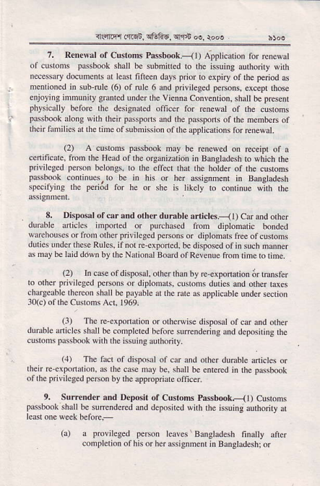
_{{'nnfl rfiE!,} ^{qGfts,} Et ^{|h d,} roos
7. Rcn€sal of Clstons Pasbmk.-<l) Applicarion fo! rerewat of custons plssb@k sndl bc subniued ro rhe issuing alrhoiry with n4essn.y docnncnts ar lea$ fitleen days ^{prior} to expiry oi lhe ^{perlod} as nrenrioncd i. _{sub-rule} ⁽⁶⁾ of nle 6 aod pirileeed ^{persons.} excepr those enjoying inrnrniry gnnrcd under fte v ien na Convenrion. shatl be prcsenl pbysically boloe $e desisnared oiiccr for iedewat of $e cusloms p.ssb@k along with then passpons and rhe passpons ofihe membes of ihenfddilies the dne ofsubnission ofrhe apptications torEnewat.
⁽²⁾ A cunons ^{pa$book} iat be renew€d on Beipt of a cenific e. frcn the Head olrhe oreaniz io. in Btuglldesh ro whicn the ^{privilcgcd peaon} belo.gs, lo the ellecl rhat the holder of the cusroms passbook cominues,lo be in his or her assisnncnr i. Bangladesh specitying the period for he or she is tikcly to conri.ue with lhe rssgonlenr.
8. Dispdsal of @r ,nd oth€r dtrmbl. anic|6.-( li Car and olh€r durbl€ Jniclcs imponed or ^{purchAed} fron diplonaric bonded waehouses or frcm orher ^{pri} v i lesed penons or di ^{pl} ohals f@ of clsrons duries underthese Rulcs, if nor Erxponed. bc disposed ofin such maoner as mry bc ldd ddwn by lhe Ndionrl Board of Revsnue froh ume ro !ne.
⁽²⁾ I. case of disposal, other rhao by re€xponadon 6r lEnsier to orher privile8ed ^{penodsor} diplom s, cusroo duries ano orher raies chargeable thereon shlll b€ ^{pryable!r} rherare as applicrble u.der secrion 30(c) ot rhe Cunofr s Act, 1969.
⁽³⁾ Tbc re-cxponarion oroiheNhe disposat ofcar and olher dur$le dnicics shall be cooplered before strrenderins lnd deposiring lhe c usroms prssbook wnh t he issu ins adhori ry.
^{,4,} _{tT r!!r or dFpo.,} ^{q} cr Jnd o.htr JdrJble inich" or lhen E-cxpondion. as the case may be, shall be enlcrcd in rhe pa$book oarbe prililesed p€rson by rhe apprcpriare oficei
9. Surr.nder and Deposit ^{ot Custons Passb@k.-} ₁₁₎ Cusods _{F.,boo\.hrl} be sumndered rrd 'leN.reJ ^{(irh rr F,uiniJurhonry} I
(a) a pbvileged peBon lcales Brnstadesh fi.a ^{y} airer conplerior ofhis orherassignnenr in BlnStrdesh; or
_{r1.4fiq1 drci.} !GF6. ^{qfJn} @, $N
A privileB.d pc6on 6igns or gels teninalcd fom the
(b)
dsiSrdent for shhh be or sbe was considered |o be a
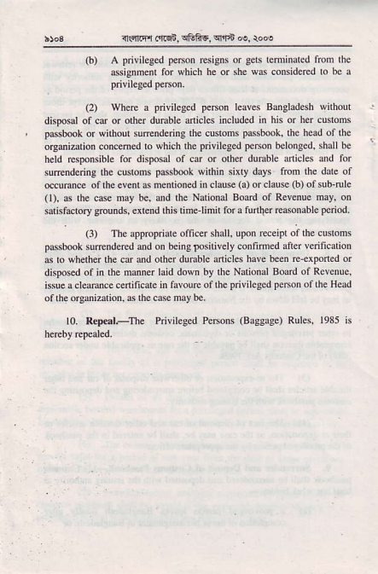
(2) Wh@ a privileged peBon lqva Bugl.desh wilhont disposdl of @ or other dunble anicl6 inclu(M in his ot hd cnslons passbek or withour su@nd.dng lhe custds pNb@k rhe head ollhc or8di2a o, concemed lo whicn the prieileged p€non belong.d, shall b€ held Gponsrbl. for dispcal of car or olher dunble dicles and for suftndqing the cutoDs pdsltuk eithin sixty days frcm the dotc of @umc. of the .v.nl s m.nrio.ed in claus {a) or claue (b) or sub-ruI€ (l), d rh. c6e nay b., dd the Natonal Board of ReY.DUc nay, on etisfactory grounds, ertend this tinelimit for a lurtier rcoenable period,
(l) The _{tppropriare omcet rholl. upon} (c.ipr oithe cusrom. prssbmk s!ftndeEd dd on ^{b.ing} _{Fsitiy€ly} confimed afier vdficalon s ro *h€ther $e cd ed oln r duEble anicl6 have b.en re+xPoned or dispNd of in $e ndner laid down by the National B@.d of Revenuc, hsue a ctaec. c.nificatc in favoure of $e privilc8pd person of the Hcad oi $e oremizrtion, as lhe .ase nay b€.
l0- Re!€.|;Ihe Privileeed PeMm {Ba33,4e) Rules. 1935 is
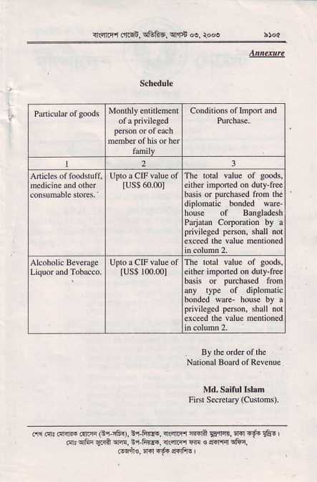
_{<r€r.ta otq!.} qtrFa. ^{q.ln} d. to.a
Cooditions of lmpon and
2 l
_{lus$} 6o_ml^{Th€ lolal value of goorrs,}
either inponed on dury-free
basis or purchded fDn the
diplomtic bonded waE
nous of Bangladesh
Pdaim Corporation by a
privjlcged peMn, shall not
exceed rne valu. nc.lioned
_{IUS$} 100.001^{The roral value or goods,}
enher inponed on duly-rEe
_{basis or} ^{p!6ha*d} fron
any ryp€ of diplonar'c
bond€d ware- houe by a
privilcged pe6on, shall not
excccd ln€ Yalue menlioned
Naional Bodd olRevenue
Fni SaErory (Cusront,
cri Fr! dr.rm rarn _{G'i.i6r),} ii-F f.. n rn r{.d _{EqrB,} lrdFf{rE. I Fl.qli. srrA m, ir F*[., i(.r@ @ € _{s_.rrFl} qRn,
_{@ir€.} ^{q.]} _{!E+} ^{q4flE} ,

